Graded Assignment on Serverless Architecture

Automated Instance Management Using AWS Lambda and Boto3

1. Setup:

Create two EC2 instances.

Tag one of them as `Auto-Stop ` and the other as `Auto-Start`.

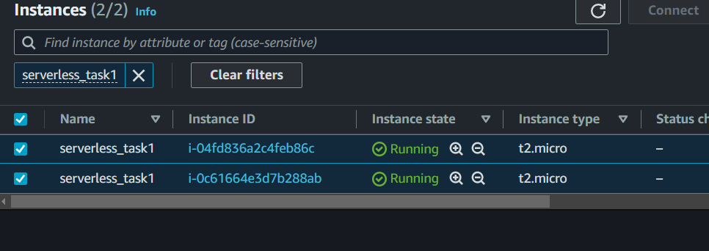

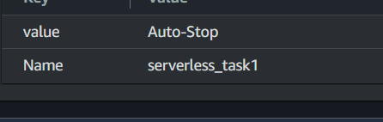

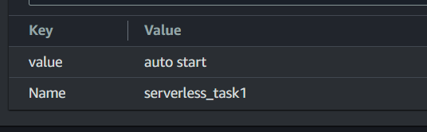

1. Lambda Function Creation: -

Set up an AWS Lambda function.

Ensure that the Lambda function has the necessary IAM permissions to describe, stop, and start EC2 instances.





3.Coding: - Using Boto3 in the Lambda function: -

Detect all EC2 instances with the `Auto-Stop ` tag and stop them.

Detect all EC2 instances with the `Auto-Start` tag and start them.

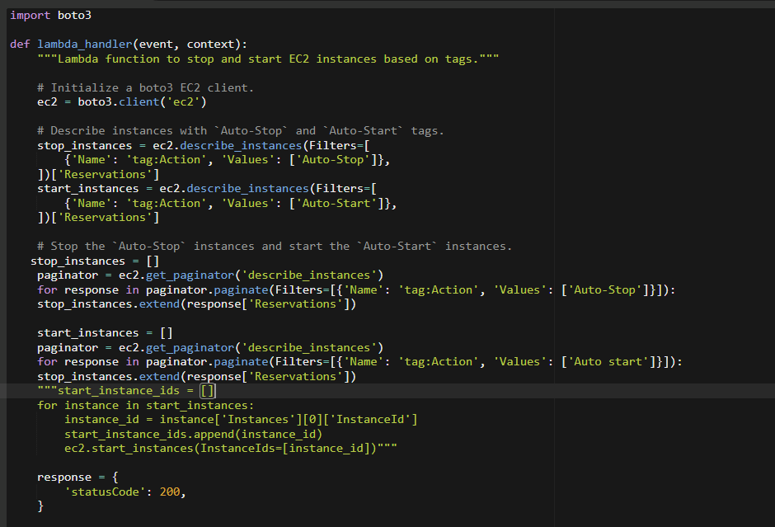

4.Testing: - Manually invoke the Lambda function.

Confirm that the instance tagged `Auto-Stop ` stops and the one tagged `Auto-Start` starts

